Simulating Drought Events

# Introduction

This paper is an investigation of a method to analyze historical drought reconstructions for the goal of giving water supply managers a better idea of how to anticipate future drought events. Drought is a difficult thing to define and describe quantitatively. Flooding, because of the generally short durations of flood events and they are easier to measure. Droughts are a longer “creeping disaster” that people often don’t realize the magnitude of until the lack of water is evident in the death of crops, trees, and dramatic water level declines in their recreational and water supply reservoirs. This investigation is in 2 parts: first drought will be described mathematically and then simulated; second, the mathematical drought description will be used to simulate reservoir inflows, evaporation and precipitation for years before those data were recorded. Reservoir models will be run to determine the firm yield of a particular reservoir according to the new data, and an analysis of the variance and error will be discussed.

# Background

The design of reservoirs in Texas is done by using the longest available precipitations, evaporation and inflow data available. Reservoir models are then run using these data to determine what the firm yield of the reservoir is so that water rights can be allocated. Tree rings have been studied in recent years as indicators of drought. Each year the bands that indicate tree growth are correlated with available precipitation and evaporation data (called net evaporation) and historical stream flows with what is known as the Palmer Drought Index (PDI). The Index is essentially “reconstructed” for the years where tree ring information exists, but net evaporation and stream flow data does not exist. In the Dallas region, there are several reconstructions that may prove useful to water supply managers, since the available tree ring data and thus the drought reconstructions go back all the way to the year 998.

# Model Formulation

Drought is a function of two variables: duration and severity. Figure 1 is a schematic that shows this. Thus there is a probability distribution that can describe each of these variables separately. The data for the drought reconstruction comes from (Cook et al., 1999) and is shown in Figure 2. The reconstruction is combined with actual measured data for the period of record, which is shown in Figure 3, and clearly shows what water suppliers have called the “drought of record.” Modeling this data involves 3 steps:

1. Describing the Severity, and the Duration components of drought individually, with probability distributions (henceforth, *marginal* distributions)
2. Combining the two marginal distributions into a single bivariate distribution that accounts for the dependence of the two variables on each other
3. Simulating the data by generating random variables for each severity and duration.

Figure 1. Schematic for Duration (d), Severity (s), and Interarrival Time (t).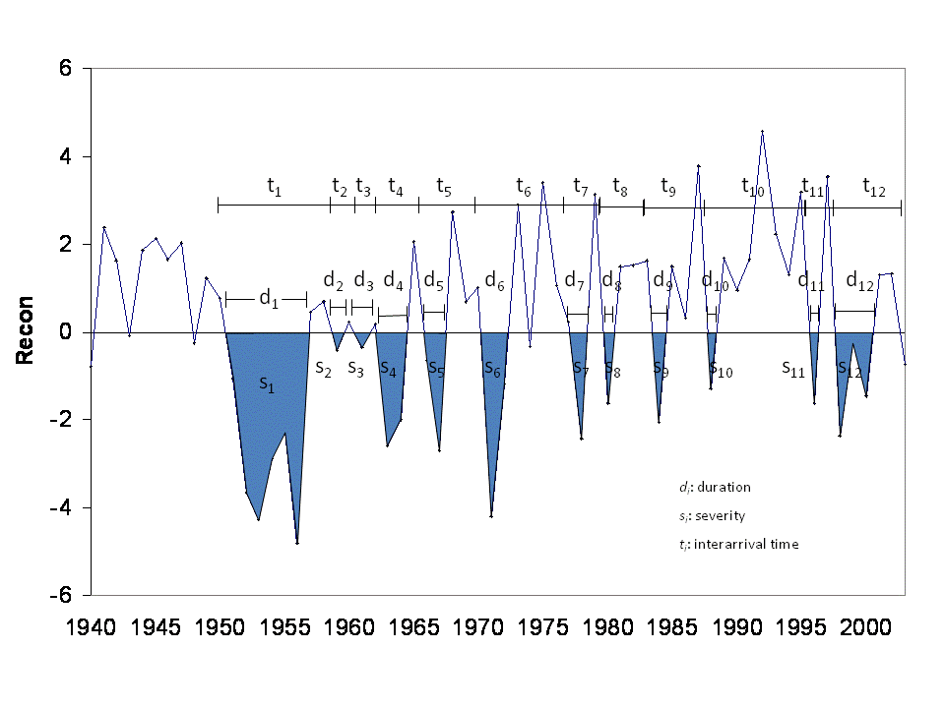

Figure 2. Parmer Drought Index Reconstruction

Figure 3. Palmer Drought Index (Period of Record)

# Solution Approach

In order to actually pull a list of droughts with their severity and duration information from the 100 year record, a small piece of code was needed. This code is describes in Appendix A. The code parses the reconstruction for years where the PDI was less than 0, and if more that one year in a row were less than 0, it consolidated the years into a single “drought event.” The code returned 195 drought events with durations 1 year or greater, with their corresponding durations, severities, and interarrival times (tn in Figure 1).

## Univariate Descriptions (Marginal Distributions for Severity and Duration)

Once the drought record was established the droughts were analyzed using gamma distributions and fitted gamma distributions were developed using the method of least squares. The cumulative distribution functions for the drought’s duration and severity are shown below in Figures 4 and 5.

The gamma distribution (cdf):



P is the probability that a single from the gamma distribution (with parameters a and b) fall in the interval [0,x] (Mathworks, 2010).

Since both duration and severity use the same distribution, only the parameters change for each:

Table 1. Parameters Used for Respective Marginal Distributions

|  |  |  |
| --- | --- | --- |
|  | a | b |
| Duration | 0.82 | 2.82 |
| Severity | 0.86 | 6.3 |

Figure 4. Observed Drought Severity with Fitted Gamma Distribution

Figure 5. Observed Drought Duration with Fitted Gamma Distribution

## Multivariate Description of Drought

The choice for the bivariate description of drought was done by evaluating various different copulas in the statistical software R. There are various methods to determine fit, and the routines within the program determine the “log-likelihood” that a particular distribution fits the data. The copula that fit the best was described by Shiau (2003) and used for the modeling of drought in this paper. The joint cumulative distribution function used is:

$$F\left(x,y\right)=e^{-{\left[{(-lnF\left(x\right)}^{m}\right)+{(-lnF\left(y\right))}^{m}]}^{\frac{1}{m}}}$$

where $F\left(x\right)$ and $F\left(y\right)$ are the marginal distributions for random variables *X* (duration) and *Y* (severity);

$$m≥1$$

$$and m=\frac{1}{\sqrt{1-ρ}}$$

where $ρ$ is the correlation coefficient for *X* between *Y*.

The recurrence interval of the drought can be calculated from the above bivariate distribution and:

$$E\left(T\right)=\frac{E\left(L\right)}{1-F\left(x,y\right)}$$

$E\left(T\right)$ is the recurrence interval and $E\left(L\right)$ is the expected (average) interarrival time (tn from Figure 1).

Figure 6. Drought Recurrence Intervals with Historical Drought Eventsdrought slide.tif

# Generating Random Variables (Simulation)

Using the Inverse Transform Method on each of the marginal distributions, random variables were generated. They are displayed as pairs for duration and severity below in Figure 7.

Figure 7. Randomly Generated Variables

# Analysis of Bivariate Model (Simulation)

The pairs of randomly generated Drought and Severity shown in Figure 7 do not exhibit the dependence that one sees from the historical data in Figure 6. The true nature of drought suggests a high degree of dependence in the 2 variables, the reason being that drought severity is a function of its duration. In effect, the simulated data should adhere to the “shape” of the plotted historical drought events shown in Figure 6. In order to simulate this relationship properly, different methods must be used. In the literature there are iterative procedures that can accomplish this description of dependence and these will be researched and covered in a future report.

# Conclusion

The description and modeling of drought events was attempted in this paper. While the description of drought contained here is appropriate, simulating drought events by generating random variables from each distribution does not achieve an accurate picture of drought. Further research is required to better understand the simulation of random variable generation through bivariate distributions, though this effort was a valuable step in the process.

# References

Cook, E. R., D. M. Meko, D. W. Stahle, and M. K. Cleaveland (1999), Drought reconstructions for the continental United States, J. Clim., 12, 1145–1162. Data developed by Cook, et al was downloaded from <http://www.ncdc.noaa.gov/>

Mathworks, (2010). MATLAB Documentation for Statistics Toolbox: Gamma Distribution. Accessed at <http://www.mathworks.com/access/helpdesk/help/toolbox/stats/brn2ivz-39.html>

Shiau, J.T. (2003), Return period of bivariate distributed extreme hydrological events. Stochastic Environmental Research and Risk Assessment, 17, 42-57.

Appendix A. Code for Extraction of Drought Events

Sub Find_droughts()

is_drought = False

numrecon = 1008

j = 0

ReconTally = 0

PrintMe = False

yearTally = 0

interarrival = 0

Dim recon As Range

Set recon = Worksheets("recon").Range("B3:B1010")

For i = 1 To numrecon

If recon(i) < 0 And Not is_drought Then

is_drought = True

j = j + 1

ReconTally = recon(i)

yearTally = 1

interarrivalTime = i - interarrival

interarrival = i

ElseIf recon(i) < 0 And is_drought Then

ReconTally = ReconTally + recon(i)

yearTally = yearTally + 1

ElseIf recon(i) >= 0 And is_drought Then

is_drought = False

DroughtArray(j) = ReconTally

yearArray(j) = yearTally

ReconTally = 0

PrintMe = True

End If

If PrintMe Then

Cells(j + 1, 4) = DroughtArray(j)

Cells(j + 1, 5) = yearArray(j)

Cells(j + 1, 6) = interarrivalTime

PrintMe = False

End If

Next i

End Sub

Appendix B. List of Drought Events

|  |  |  |  |  |
| --- | --- | --- | --- | --- |
| **Start Year** | **End Year** | **Severity** | **Duration** | **Interarrival Time** |
| 998 | 1000 | -7.545 | 3 | 2 |
| 1003 | 1016 | -28.51 | 14 | 5 |
| 1020 | 1025 | -8.395 | 6 | 17 |
| 1028 | 1029 | -1.914 | 2 | 8 |
| 1032 | 1036 | -5.376 | 5 | 4 |
| 1038 | 1045 | -15.449 | 8 | 6 |
| 1047 | 1051 | -7.414 | 5 | 9 |
| 1057 | 1057 | -0.74 | 1 | 10 |
| 1061 | 1063 | -9.135 | 3 | 4 |
| 1066 | 1066 | -0.132 | 1 | 5 |
| 1069 | 1082 | -25.859 | 14 | 3 |
| 1085 | 1086 | -4.481 | 2 | 16 |
| 1089 | 1092 | -6.792 | 4 | 4 |
| 1099 | 1101 | -4.94 | 3 | 10 |
| 1103 | 1104 | -6.003 | 2 | 4 |
| 1107 | 1112 | -12.244 | 6 | 4 |
| 1115 | 1119 | -9.001 | 5 | 8 |
| 1121 | 1134 | -36.018 | 14 | 6 |
| 1137 | 1146 | -16.383 | 10 | 16 |
| 1148 | 1164 | -34.043 | 17 | 11 |
| 1167 | 1167 | -0.755 | 1 | 19 |
| 1181 | 1181 | -0.676 | 1 | 14 |
| 1183 | 1187 | -7.652 | 5 | 2 |
| 1192 | 1195 | -4.546 | 4 | 9 |
| 1198 | 1204 | -16.47 | 7 | 6 |
| 1207 | 1217 | -27.78 | 11 | 9 |
| 1221 | 1226 | -13.637 | 6 | 14 |
| 1229 | 1234 | -17.312 | 6 | 8 |
| 1236 | 1242 | -19.757 | 7 | 7 |
| 1244 | 1251 | -12.442 | 8 | 8 |
| 1254 | 1256 | -10.241 | 3 | 10 |
| 1258 | 1258 | -0.753 | 1 | 4 |
| 1260 | 1261 | -1.322 | 2 | 2 |
| 1269 | 1270 | -3.234 | 2 | 9 |
| 1272 | 1272 | -0.192 | 1 | 3 |
| 1274 | 1277 | -8.634 | 4 | 2 |
| 1279 | 1279 | -1.725 | 1 | 5 |
| 1281 | 1281 | -0.686 | 1 | 2 |
| 1283 | 1283 | -1.583 | 1 | 2 |
| 1287 | 1289 | -4.709 | 3 | 4 |
| 1291 | 1294 | -11.071 | 4 | 4 |
| 1296 | 1297 | -3.64 | 2 | 5 |
| 1299 | 1303 | -7.254 | 5 | 3 |
| 1305 | 1308 | -8.884 | 4 | 6 |
| 1310 | 1310 | -1.564 | 1 | 5 |
| 1315 | 1317 | -8.111 | 3 | 5 |
| 1319 | 1320 | -4.061 | 2 | 4 |
| 1322 | 1322 | -1.32 | 1 | 3 |
| 1325 | 1325 | -0.138 | 1 | 3 |
| 1327 | 1329 | -2.992 | 3 | 2 |
| 1336 | 1336 | -1.866 | 1 | 9 |
| 1345 | 1347 | -7.128 | 3 | 9 |
| 1349 | 1355 | -10.96 | 7 | 4 |
| 1358 | 1358 | -2.315 | 1 | 9 |
| 1360 | 1361 | -4.808 | 2 | 2 |
| 1364 | 1367 | -8.413 | 4 | 4 |
| 1369 | 1372 | -11.102 | 4 | 5 |
| 1374 | 1376 | -6.322 | 3 | 5 |
| 1378 | 1379 | -1.187 | 2 | 4 |
| 1381 | 1384 | -6.801 | 4 | 3 |
| 1386 | 1387 | -5.956 | 2 | 5 |
| 1390 | 1390 | -1.003 | 1 | 4 |
| 1392 | 1393 | -1.549 | 2 | 2 |
| 1397 | 1397 | -1.018 | 1 | 5 |
| 1400 | 1402 | -2.246 | 3 | 3 |
| 1404 | 1405 | -1.6 | 2 | 4 |
| 1410 | 1412 | -6.477 | 3 | 6 |
| 1415 | 1415 | -2.296 | 1 | 5 |
| 1418 | 1419 | -1.544 | 2 | 3 |
| 1421 | 1422 | -7.187 | 2 | 3 |
| 1424 | 1425 | -3.948 | 2 | 3 |
| 1427 | 1427 | -2.522 | 1 | 3 |
| 1430 | 1431 | -2.897 | 2 | 3 |
| 1433 | 1433 | -0.371 | 1 | 3 |
| 1436 | 1437 | -4.04 | 2 | 3 |
| 1440 | 1440 | -0.886 | 1 | 4 |
| 1442 | 1442 | -0.324 | 1 | 2 |
| 1444 | 1447 | -11.141 | 4 | 2 |
| 1450 | 1451 | -4.321 | 2 | 6 |
| 1453 | 1463 | -29.377 | 11 | 3 |
| 1468 | 1473 | -11.721 | 6 | 15 |
| 1481 | 1481 | -2.089 | 1 | 13 |
| 1483 | 1483 | -0.007 | 1 | 2 |
| 1488 | 1490 | -3.663 | 3 | 5 |
| 1492 | 1492 | -0.009 | 1 | 4 |
| 1496 | 1497 | -8.786 | 2 | 4 |
| 1501 | 1507 | -12.855 | 7 | 5 |
| 1510 | 1512 | -6.793 | 3 | 9 |
| 1514 | 1516 | -1.221 | 3 | 4 |
| 1518 | 1518 | -0.785 | 1 | 4 |
| 1521 | 1521 | -0.42 | 1 | 3 |
| 1524 | 1525 | -5.721 | 2 | 3 |
| 1527 | 1530 | -7.438 | 4 | 3 |
| 1532 | 1533 | -3.969 | 2 | 5 |
| 1535 | 1535 | -1.773 | 1 | 3 |
| 1542 | 1544 | -8.839 | 3 | 7 |
| 1547 | 1547 | -0.375 | 1 | 5 |
| 1555 | 1556 | -1.752 | 2 | 8 |
| 1560 | 1561 | -4.619 | 2 | 5 |
| 1563 | 1563 | -0.561 | 1 | 3 |
| 1566 | 1574 | -15.485 | 9 | 3 |
| 1577 | 1577 | -3.207 | 1 | 11 |
| 1581 | 1582 | -1.424 | 2 | 4 |
| 1585 | 1585 | -0.36 | 1 | 4 |
| 1590 | 1592 | -2.697 | 3 | 5 |
| 1595 | 1595 | -1.684 | 1 | 5 |
| 1597 | 1601 | -9.741 | 5 | 2 |
| 1608 | 1608 | -3.556 | 1 | 11 |
| 1616 | 1616 | -0.612 | 1 | 8 |
| 1618 | 1619 | -3.09 | 2 | 2 |
| 1623 | 1623 | -1.859 | 1 | 5 |
| 1625 | 1627 | -8.805 | 3 | 2 |
| 1630 | 1632 | -6.251 | 3 | 5 |
| 1638 | 1638 | -1.426 | 1 | 8 |
| 1641 | 1648 | -14.694 | 8 | 3 |
| 1652 | 1652 | -0.919 | 1 | 11 |
| 1654 | 1654 | -4.089 | 1 | 2 |
| 1656 | 1656 | -0.743 | 1 | 2 |
| 1658 | 1659 | -2.186 | 2 | 2 |
| 1661 | 1661 | -0.312 | 1 | 3 |
| 1664 | 1664 | -1.623 | 1 | 3 |
| 1666 | 1666 | -0.629 | 1 | 2 |
| 1670 | 1670 | -3.613 | 1 | 4 |
| 1673 | 1673 | -0.598 | 1 | 3 |
| 1675 | 1676 | -5.836 | 2 | 2 |
| 1681 | 1682 | -5.76 | 2 | 6 |
| 1684 | 1685 | -4.578 | 2 | 3 |
| 1687 | 1691 | -5.608 | 5 | 3 |
| 1693 | 1693 | -0.146 | 1 | 6 |
| 1696 | 1699 | -7.019 | 4 | 3 |
| 1703 | 1705 | -7.836 | 3 | 7 |
| 1708 | 1710 | -3.594 | 3 | 5 |
| 1712 | 1712 | -0.427 | 1 | 4 |
| 1714 | 1717 | -7.654 | 4 | 2 |
| 1722 | 1722 | -1.649 | 1 | 8 |
| 1724 | 1725 | -3.326 | 2 | 2 |
| 1727 | 1731 | -11.206 | 5 | 3 |
| 1734 | 1734 | -0.376 | 1 | 7 |
| 1736 | 1738 | -6.569 | 3 | 2 |
| 1741 | 1743 | -3.869 | 3 | 5 |
| 1750 | 1757 | -14.353 | 8 | 9 |
| 1763 | 1769 | -6.87 | 7 | 13 |
| 1772 | 1778 | -14.531 | 7 | 9 |
| 1780 | 1780 | -1.657 | 1 | 8 |
| 1785 | 1786 | -7 | 2 | 5 |
| 1789 | 1791 | -8.659 | 3 | 4 |
| 1798 | 1798 | -0.804 | 1 | 9 |
| 1800 | 1801 | -4.476 | 2 | 2 |
| 1805 | 1806 | -6.619 | 2 | 5 |
| 1808 | 1808 | -1.911 | 1 | 3 |
| 1812 | 1812 | -0.9 | 1 | 4 |
| 1816 | 1816 | -0.373 | 1 | 4 |
| 1819 | 1820 | -3.367 | 2 | 3 |
| 1822 | 1822 | -3.258 | 1 | 3 |
| 1824 | 1824 | -3.95 | 1 | 2 |
| 1829 | 1832 | -5.176 | 4 | 5 |
| 1835 | 1835 | -1.535 | 1 | 6 |
| 1837 | 1839 | -2.818 | 3 | 2 |
| 1841 | 1842 | -6.662 | 2 | 4 |
| 1845 | 1848 | -4.245 | 4 | 4 |
| 1852 | 1852 | -0.441 | 1 | 7 |
| 1854 | 1857 | -10.877 | 4 | 2 |
| 1859 | 1864 | -17.239 | 6 | 5 |
| 1874 | 1874 | -2.265 | 1 | 15 |
| 1879 | 1880 | -2.853 | 2 | 5 |
| 1886 | 1887 | -7.578 | 2 | 7 |
| 1889 | 1889 | -0.9 | 1 | 3 |
| 1893 | 1897 | -7.837 | 5 | 4 |
| 1899 | 1899 | -0.285 | 1 | 6 |
| 1901 | 1902 | -5.042 | 2 | 2 |
| 1904 | 1904 | -1.646 | 1 | 3 |
| 1906 | 1906 | -0.518 | 1 | 2 |
| 1909 | 1911 | -4.416 | 3 | 3 |
| 1913 | 1913 | -1.569 | 1 | 4 |
| 1916 | 1918 | -7.919 | 3 | 3 |
| 1925 | 1925 | -6.444 | 1 | 9 |
| 1931 | 1931 | -0.209 | 1 | 6 |
| 1934 | 1934 | -2.673 | 1 | 3 |
| 1936 | 1940 | -6.475 | 5 | 2 |
| 1943 | 1943 | -0.102 | 1 | 7 |
| 1948 | 1948 | -0.246 | 1 | 5 |
| 1951 | 1956 | -18.978 | 6 | 3 |
| 1959 | 1959 | -0.417 | 1 | 8 |
| 1961 | 1961 | -0.363 | 1 | 2 |
| 1963 | 1964 | -4.609 | 2 | 2 |
| 1966 | 1967 | -3.354 | 2 | 3 |
| 1971 | 1972 | -5.399 | 2 | 5 |
| 1974 | 1974 | -0.342 | 1 | 3 |
| 1978 | 1978 | -2.435 | 1 | 4 |
| 1980 | 1980 | -1.617 | 1 | 2 |
| 1984 | 1984 | -2.062 | 1 | 4 |
| 1988 | 1988 | -1.306 | 1 | 4 |
| 1996 | 1996 | -1.619 | 1 | 8 |
| 1998 | 2000 | -4.101 | 3 | 2 |
| 2003 | 2003 | -0.726 | 1 | 5 |